**PROJECT REPORT**

**Google Stock Price Prediction**

*Submitted towards the partial fulfillment of the criteria for Internship*

*Submitted By:*

*Karthik Kumar G*

# Abstract

Recurrent Neural Networks are the first of its kind State of the Art algorithms that can Memorize/remember previous inputs in memory, When a huge set of Sequential data is given to it. Recurrent Neural Networks are the first of its kind State of the Art algorithms that can Memorize/remember previous inputs in memory, When a huge set of Sequential data is given to it.

These loops make recurrent neural networks seem kind of mysterious. However, if you think a bit more, it turns out that they aren’t all that different than a normal neural network. A recurrent neural network can be thought of as multiple copies of the same network, each passing a message to a successor.

#### **The Problem of Long-Term Dependencies.**

#### **Long Short Term Memory (LSTM) Networks**

Long Short Term Memory networks – usually just called “LSTMs” – are a special kind of RNN, capable of learning long-term dependencies.

LSTMs are explicitly designed to avoid the long-term dependency problem. Remembering information for long periods of time is practically their default behavior, not something they struggle to learn.

**In this Project** :

Breaking up of Data into chunks(60 Days), and training our model on this 60 days of Data ,

And making Prediction on 61st day and so on.

Data consists of Google’s stock price Data from oct 2004 to the present Day.

*.*

**List of Tables**

# CHAPTER 1: INTRODUCTION

## Title & Objective of the study

#### To Build stock prediction model

## 1.2 Data Sources

<https://finance.yahoo.com/quote/GOOG/history/>

## 1.3 Tools & Techniques

Tools: Python

### **Techniques**: RNN – LSTM, Tensor flow, Keras

# CHAPTER 2: DATA PREPARATION AND UNDERSTANDING

## 2.1 Phase I – Data Extraction and Cleaning:

* **Missing Value Analysis and Treatment**
* **Handling Outliers**
* **Feature Extraction**

#### 

#### **2.2 Steps to build stock prediction model**

* **Data Preprocessing**
* **Building the RNN**
* **Making the prediction and visualization**

**2.3 Exploratory Data Analysis:**

# CHAPTER 3: Splitting DATA

* **Training Data-[**from oct 2004 to 2019**]**
* **Test Data-[**from 2019 to present**]**

### CHAPTER 4: Building LSTM

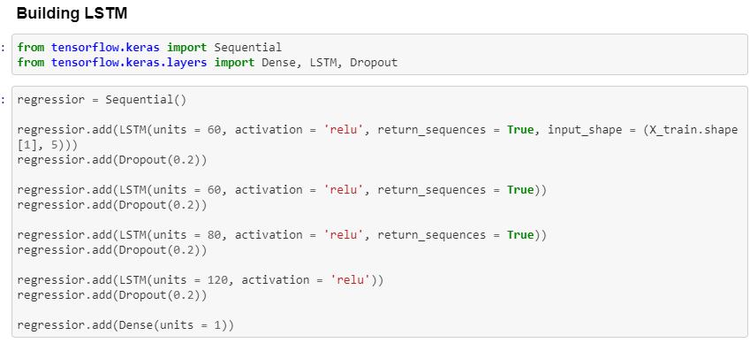

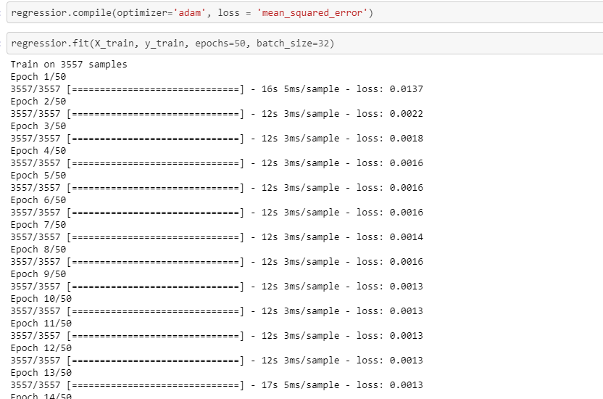

CHAPTER 6: RECOMMENDATIONS AND CONCLUSION

* By changing values of the units like Dropouts ,Units or Epochs in the above code we can achieve lower loss . that means better Accuracy

**Visualization**

